**Supporting Information for**

**Central electron-enriched NO-FeN4 sites as superior acidic oxygen reduction reaction electrocatalyst for proton exchange membrane fuel cell**

**S1. Experimental Section**

**Structural Characterization:**

The transmission electron microscopy (TEM) was taken on a HT-7700 field-emission electron microscope operated at an acceleration voltage of 100 kV. X-ray powder diffraction (XRD) was presented using a Philips X’Pert Pro Super diffractometer with Cu-Kα radiation (λ = 1.54178 Å).The field-emission scanning electron microscopy(FE-SEM) images were excuted on a JEOL JSM-6700F SEM. X-ray photoelectron spectra (XPS) were acquired on an ESCALAB MK II X-ray photoelectron spectrometer with Mg Kα as the excitation source. The high-resolution TEM (HRTEM), high-angle annular dark-field scanning transmission electron microscopy (HAADF-STEM) and corresponding energy-dispersive spectroscopy (EDS) mapping analyses were performed on a JEOL JEM-ARF200F TEM/STEM with a spherical aberration corrector. The nitrogen adsorption-desorption isotherms and corresponding pore size distribution were evaluated using a Micromeritics ASAP 2000 system at 77 K. Fe L-edge, C K-edge and N K-edge XANES spectra were measured at the beamline U19 of National Synchrotron Radiation Laboratory (NSRL, Hefei) in the total electron yield (TEY) mode by collecting the sample drain current under a vacuum better than 10-7 Pa. The absorption spectra of Fe K-edge were collected in transmission mode using a Si (111) double-crystal monochromator at the X-ray absorption fine structure (XAFS) station of the 1W1B beamline of the Beijing Synchrotron Radiation Facility (BSRF).

**Electrochemical Measurements:**

The electrochemical tests were carried out in a three-electrode system on an electrochemical workstation (CHI760E). A glassy carbon (GC) electrode (diameter of 5 mm with surface area of 0.196 cm2), a graphite rod and an Ag/AgCl (3.5M KCl) were used as working electrode, counter electrode and reference electrode, respectively. All of the potentials were calibrated to the reversible hydrogen electrode (RHE) according to Nernst equation. To prepare the working electrode, 4 mg catalysts mixed with 40 μl Nafion solution (Sigma Aldrich, 5wt %) were disperesd into 1 ml isopropanol and water mixture solution (volume ratio: 3:1) and sonicated for at least 60 min to form a homogeneous catalyst ink. A certain volume of catalyst ink was then drop-casted onto the glassy carbon electrode with a 0.6 mg cm-2 loading for all samples.

Before ORR catalytic activity testing, oxygen was used to purge the 0.5 M H2SO4 solution for 30 min to keep the solution oxygen saturation. The working electrodes were activated using CV test at a scan rate of 50 mV s-1 for several times before Cyclic voltammetry (CV) and Linear sweep voltammetry (LSV) tests. The linear sweep voltammetry (LSV) were carried out at a scan rate of 10 mV s-1. Electrochemical impedance spectroscopy (EIS) measurements were measured by applying an AC voltage with 5 mV amplitude in a frequency range from 100 KHz to 100 mHz under 0.5 M H2SO4 solution. The polarization curves of the ORR was measured from 0.2 to 1.1 V (*vs.* RHE) at a scan rate of 10 mV s-1 with a series of rotating electrode speeds (900, 1225, 1600, 2025 and 2500 rpm). The Pt/C (20 wt% Pt) catalyst which is considered to be one of the best ORR electrocatalysts was used as the reference material.

For rotating ring disk electrode test, the disk electrode was scanned at a rate of 10 mV s-1 and the ring electrode potential was set to 1.20 V vs. RHE. The electron transfer number (n) and hydrogen peroxide yield (H2O2 %) and were calculated by the following equations:

$n=4×\frac{I_{D}×N}{I_{D}×N+I_{R}}$ (1)

$H_{2}O_{2}\%=200×\frac{I_{R}}{I_{D}×N+I_{R}}$ (2)

ID is the disk current, IR is the ring current, and N = 0.4 is the current collection efficiency of the platinum ring.

The turn-over frequency (TOF) is calculated following the steps below:

$$TOF=\frac{J_{k}xN_{e}}{w_{Ir}xC_{cat}xN_{A}/M_{Ir}}$$

Where Jk is the kinetic current density (A cm-2), wIr is the metal content in the catalyst, Ne stands for electron number per Coulomb 6.24 x 1018, Cat presents the catalyst loading on the electrode, NA is Avogadro constant 6.022x1023, MIr is molar mass of Ir 192.2 g﹒mol-1

**XAS Measurements**

XAS measurements of the Fe K-edge were carried out in fluorescence mode at the beamline 1W1B in the Beijing Synchrotron Radiation Facility (BSRF, Beijing, China). *Operando* XAS measurements were performed with a catalyst loaded on an air cathode by using a three-electrode half-cell. The catalysts were first dispersed in ethanol and ultrasonicated for 30 min. Then the catalyst ink was brushed on a piece of gas diffuse layer with a loading of 0.5 mg cm−2.We applied different potentials from 0.1 V to 1 V versus RHE to the air cathode in 0.5 M H2SO4 for data collection to monitor XAS spectra changes during the ORR process.The applied potential was held for 5 min to reach a steady state before each measurement. During XAS measurements, the position of the absorption edge we calibrated by using Fe foil. The *operando* XAS data were collected during one period of beam time. The position of absorption edge was defined by the point corresponding to the maximum value of the derivative curves of the XANES spectra.

**S1. The Mass spectrometry of NO-FeN4 and FeN4 precursors under calcination conditions of 650 oC.**

 

**b**

**a**

Figure S1 Mass spectrometry of NO-FeN4 and FeN4 precursors with fast heat treatment.

**S2. XRD pattern of carbon black supported NO-FeN4 product.**



Figure S2. XRD pattern of **NO-FeN4** sample.

**S3. XRD pattern of carbon black supported FeN4 product.**



Figure S3. XRD pattern of **FeN4** sample.

**S4. Raman spectrum of NO-FeN4 and FeN4 sample.**



Figure S4. Raman spectrum of NO-FeN4 and FeN4 sample.

**S5. The SEM and TEM image of as-prepared** **NO-FeN4 product.**

E:\工作\中科大吴长征老师课题组\实验数据\21 活性炭限域煅烧合成ORR催化剂\实验数据\SEM\3.21\505.tif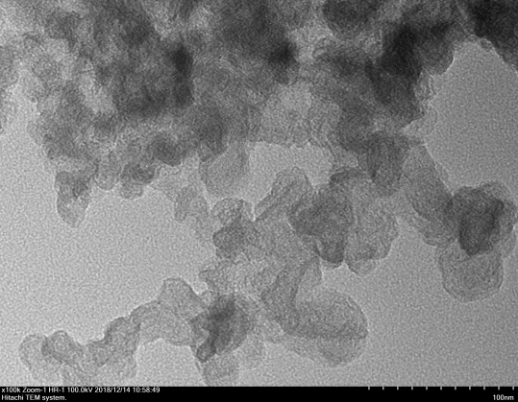

Figure S5 SEM and TEM images of NO-FeN4 sample.

**S6. The SEM and TEM image of as-prepared FeN4 product.**

E:\工作\中科大吴长征老师课题组\实验数据\21 活性炭限域煅烧合成ORR催化剂\实验数据\SEM\3.21\604.tif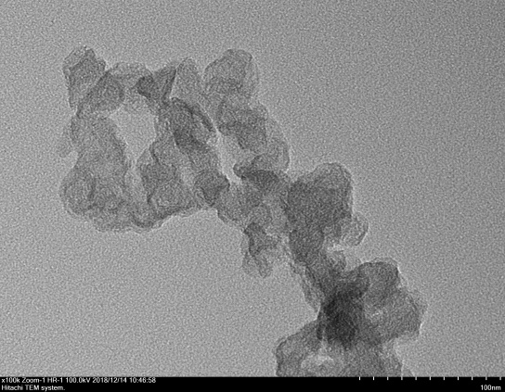

Figure S6 SEM and TEM images of FeN4 sample.

**S7. The XPS survey, XPS spectra of Zn 2p and atomic content of as-prepared NO-FeN4 product.**

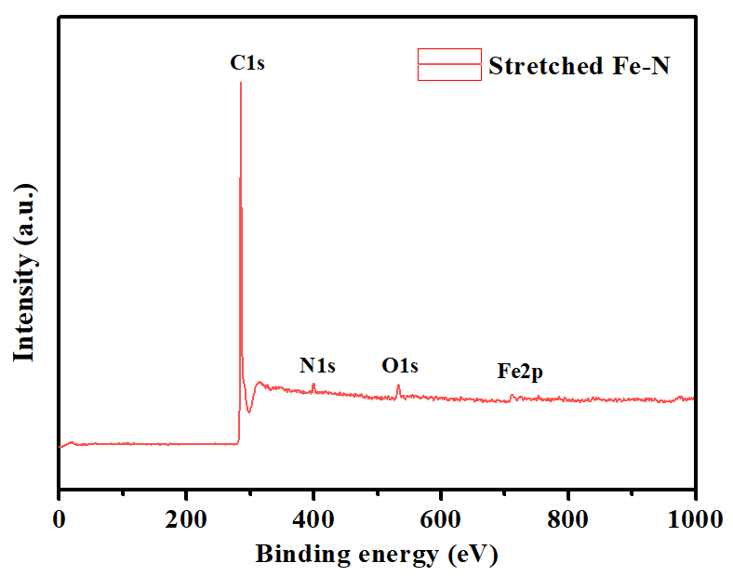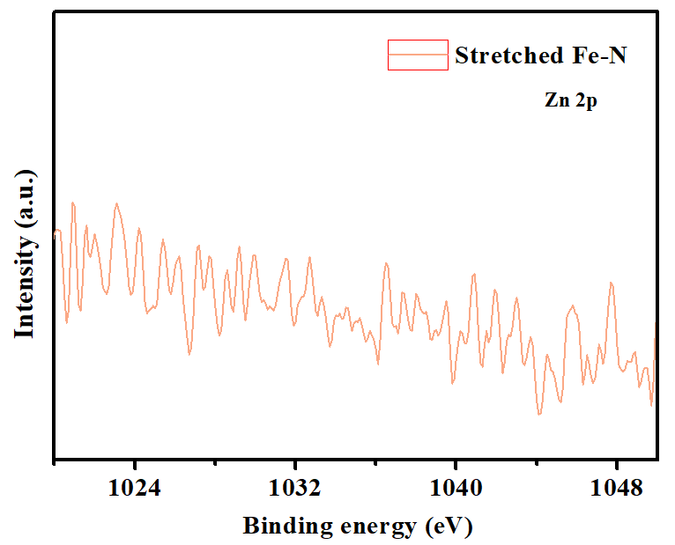

**NO-FeN4**

**NO-FeN4**

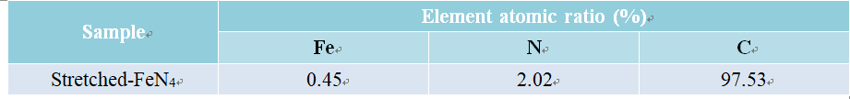

Figure S7 a) The XPS survey of as-prepared **NO-FeN4** product. c) XPS spectra of Zn 2p for NO-FeN4 sample. b) The element atomic content of all elements in the as-prepared **NO-FeN4** product.

**S8. The XPS survey and atomic content of as-prepared FeN4 product.**



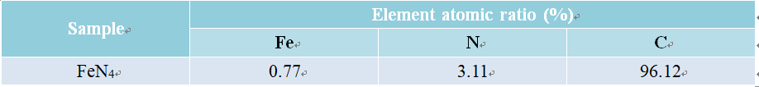

Figure S8 a) The XPS survey of as-prepared FeN4 product. b) The element atomic content of all elements in the as-prepared FeN4 product.

**S9. HRTEM and EDS-mapping of FeN4 sample.**

C:\Users\zhoutp\Desktop\工作专题\FeZn database 5.15\HRTEM\HRTEM\20190123 FeZn\ZCA\1-4.tif

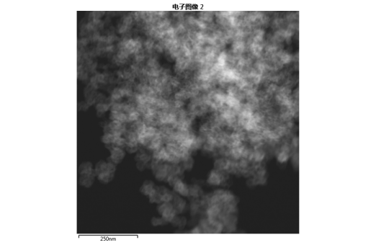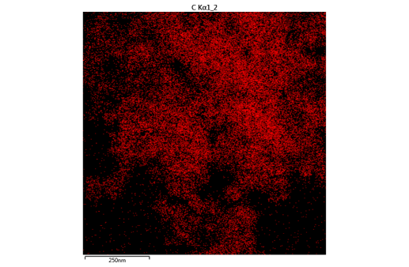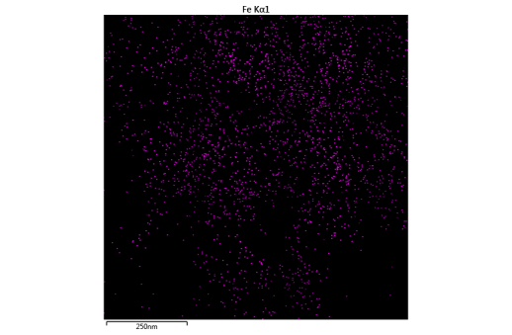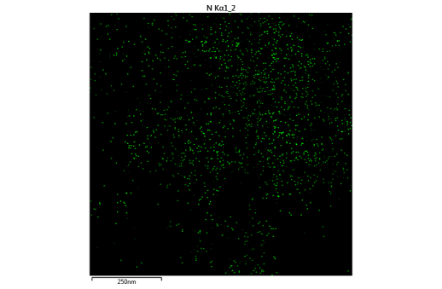

Figure S9 High-resolution transmission electron microscopy image and corresponding EDS-mapping of FeN4 sample.

**S10. Comparison between the simulations and experimental data of Fe edge of NO-FeN4 and FeN4 sample.**



Figure S10 Comparison between simulations and experimental data of a) Fe K-edge FT-EXAFS curve for NO-FeN4 and b) FeN4 product.

**S11 Optical image of NO-FeN4 catalyst**

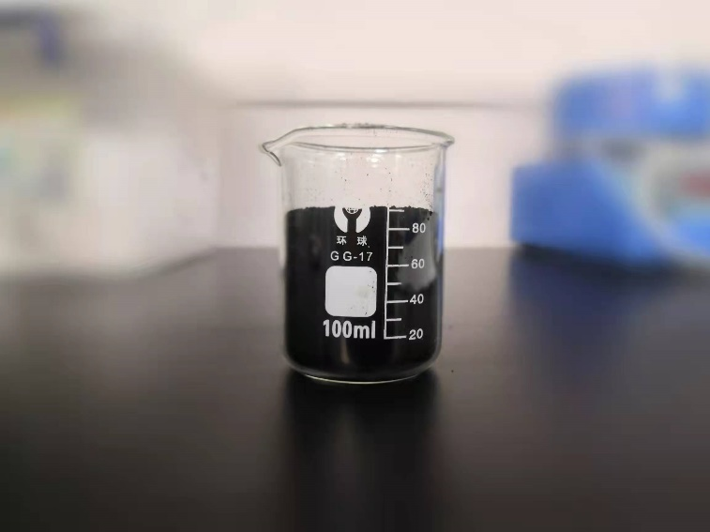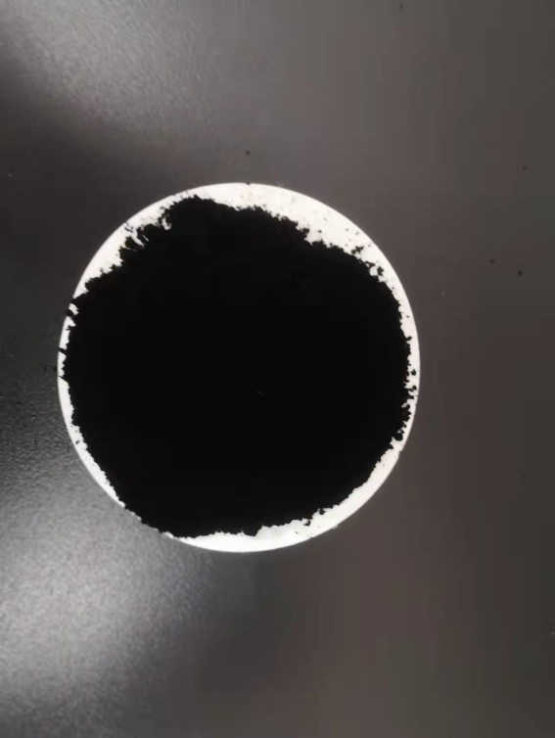

Figure S11 Optical image of NO-FeN4 catalyst

**S12. XPS of Fe 2p spectrum of NO-FeN4 and FeN4 sample.**

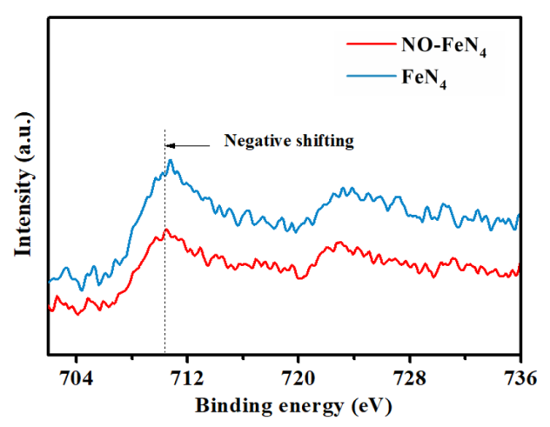

Figure S12 XPS spectra of Fe 2p for NO-FeN4 and FeN4 product.

**S13. Polarization curves at different rotating speeds and corresponding Koutechy-Levich plots at 0.8 V for NO-FeN4 and FeN4 sample.**

 

**NO-FeN4**

**NO-FeN4**

 

**FeN4**

**FeN4**

Figure S13 RDE polarization curves at different rotating speeds and corresponding Koutechy-Levich plots for different catalysts for ORR process.

**S14. Lsv curves of FeN4 catalysts before and after 7000 CV cycles.**



Figure S14 Lsv curves of FeN4 catalysts before and after 7000 CV cycles.

Table S1 Comparison of NO-FeN4 with recently reported PGM-free ORR electrocatalyst

|  |  |  |  |
| --- | --- | --- | --- |
| Catalyst | ORR performance | | Ref |
|  | E1/2  (V vs. RHE) | Electrolyte |  |
| NO-FeN4 | 0.82 | 0.5 M H2SO4 | *This work* |
| Fe-N4/C-60 | 0.80 | 0.1 M HClO4 | *Adv. Mater.* 2020, 32, 2000966 |
| Fe-N/P-C-700 | 0.72 | 0.1 M HClO4 | J. Am. Chem. Soc.2020, 142, 2404 |
| Fe0.5-N-C | 0.77 | 0.1 M HClO4 | J. Am. Chem. Soc.2019, 14, 152035. |
| p-Fe-N-CNFs | 0.74 | 0.1 M HClO4 | Energy Environ. Sci.2018, 11, 2208. |
| Fe2-Z8-C | 0.80 | 0.5 M H2SO4 | Angew. Chem. Int.Ed. 2018, 57, 1204. |
| HP-FeN4 | 0.80 | 0.5 M H2SO4 | *Energy Environ. Sci.*  2020, 13, 111. |
| TPI@Z8 (SiO2)-650-C | 0.82 | 0.5 M H2SO4 | Nat. Catal. 259.2019, 2,259 |
| SA-Fe/NG | 0.80 | 0.5 M H2SO4 | PNAS 2018, 115, 6626. |